Stage One – Analysis Model and Class design and setup

1. Case Diagram

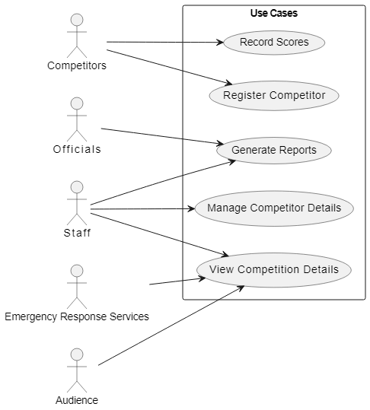

2. Class Diagram

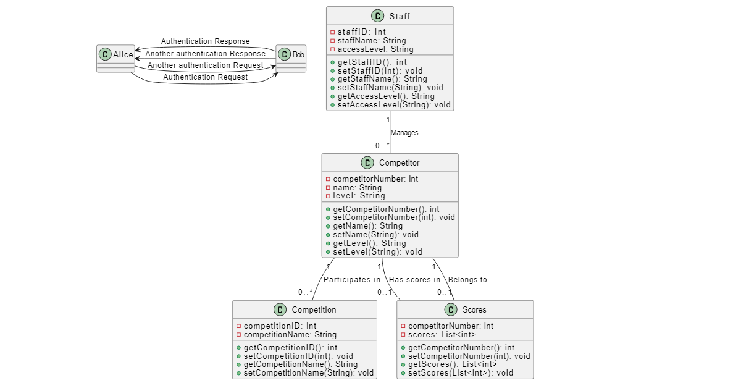

3. 3 Tier Architecture

